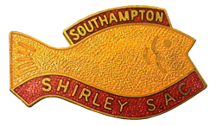

**SHIRLEY SEA ANGLING CLUB**

**SOUTHAMPTON**

**www.shirleysac.co.uk**



**COMPETITIONS CARD**

**2022**

**CELEBRATING 60 YEARS**

**1962 – 2022**

**CLUB RECORD FISH – SHORE**

**SPECIES IBS OZS KGMS CAPTOR YEAR**

**BASS 11.9 5.245 J GROVES 1976**

**BLENNY (TOMPOT) 0..3.375 0.095 RA PATTERSON 2000**

**BREAM (BLACK) 2..2.75 0.980 S PATTERSON 2004**

**BREAM (BLACK) 2..2.75 0.980 R McCLEMENTS 2018**

**BREAM (GILT HEAD) 1..5.25 0.600 D BEALE 2019**

**BULL HUSS 10..8 4.763 G PRIDAY 2019**

**COALFISH 2..4 1.021 E YOUNG 1988**

**COD 20..10.5 9.369 M HISCOTT 1983**

**CONGER EEL 38..12 17.577 P BLAKE 1989**

**DAB 1..7 0.652 A MOXON 1983**

**DOGFISH (LESSER SPOTTED) 2..9.5 1.176 W BULLEY 1994**

**DRAGONET 0..5.25 0.150 RA PATTERSON 2009**

**EEL (SILVER) 4..2.25 1.878 A MOXON 1987**

**FLOUNDER 3..5 1.503 E YOUNG 1992**

**GARFISH 1..7 0.650 G PRIDAY 2018**

**GURNARD (GREY) 0..11.25 0.319 D PANTER 2021**

**GURNARD (TUB) 1..6 0.624 A MOXON 2000**

**GURNARD (RED) 1..6.5 0.638 T JOHNSON 2003**

**HERRING 0..10.5 0.300 S THOMPSON 2007**

**JOHN DORY 1..2 0.510 R GREEN 1987**

**LANCE 0..4.25 0.120 J BELL 2011**

**LUMPSUCKER 3..1 1.390 S THOMPSON 2010**

**MACKEREL 1..14.5 0.864 A MOXON 1985**

**MULLET (THICK LIP GREY) 6..14.5 3.132 C BRADY 1989**

**MULLET (THIN LIP GREY) 3..15 1.786 R LAWRENCE 1990**

**MULLET (GOLDEN GREY) 2..8 1.134 E YOUNG 1988**

**MULLET (RED) 1..11.25 0.772 T CHAPPELL 1999**

**PIPEFISH 0..3.5 0.099 R MARTIN 1998**

**PLAICE 4..13.75 2.204 R PURKESS 1990**

**POLLACK 4..05 1.828 M HISCOTT 1986**

**POOR COD 0..7 0.198 RJ PATTERSON 1987**

**POUTING 1..13.75 0.840 RA PATTERSON 2017**

**RAY (BLONDE) 9..2 4.139 W CONSTANCE 2020**

**RAY (SMALL EYED) 10.12 4.876 O MEEK 1986**

**RAY (SPOTTED) 5..8.25 2.500 R BEALE 2007**

**RAY(STING) 37..7.8 17.006 D NEIL 2021**

**RAY(THORNBACK) 14..13 6.719 L MILAM 2021**

**RAY (UNDULATE) 14..13 6.719 K DUNHAM 2017**

**SANDEEL 0..5 0.142 R DUNHAM 1997**

**SCAD 1..0.5 0.468 A GROVES 1996**

**SHAD 1..10.5 0.751 D HAYWARD 1978**

**SHORT SPINED SCORPION 0..14.5 0.411 J HODGINS 1974**

**SMOOTHOUND 20..4 9.185 D ANDERSON 2001**

**SOLE 2..15.75 1.353 A MOXON 1999**

**TRIGGER FISH 2..10 1.191 A MOXON 1994**

**TURBOT 2..13.25 1.283 S BENCH 1998**

**WEAVER (LESSER) 0..2.5 0.071 A MOXON 1985**

**WHITING 2..13.75 1.297 M TEAGUE 1998**

**WRASSE 6..6.5 2.906 P BLAKE 1988**

**WRASSE (CUCKOO) 0..14 0.397 RJ PATTERSON 1997**

**WRASSE (CORKWING) 0..5 0.140 W CONSTANCE 2019**

**3 BEARDED ROCKLING 1..12.5 0.808 E YOUNG 1987**

**5 BEARDED ROCKILING 0.10 0.280 P MUCCI 2012**

**CLUB RECORD FISH – BOATS**

**SPECIES IBS OZS KGMS CAPTOR YEAR**

**BASS 15..8 7.031 P BRYSON 2015**

**BREAM (BLACK) 4..6 1.984 M TEAGUE 2011**

**BREAM (GILT HEAD) 0..13.5 0.380 M MUNDY 2001**

**BRILL 5..11.25 2.585 M WINSTANLEY 2008**

**BULL HUSS 16..0 7.257 K SAUNDERSON 2017**

**COALFISH 1..4.75 0.588 M EDEN 1988**

**COD 41..9.75 18.873 M EDEN 1987**

**CONGER EEL 72..0 32.658 A STEVENS 1989**

**DAB 0..15.5 0.439 A MOXON 1988**

**DRAGONET 0..2.5 0.071 T FROST 1987**

**DOGFISH (LESSER SPOTTED) 4..1.5 1.857 J JACOBS 1986**

**EEL (SILVER) 3..11.25 1.680 D BROOKS 1983**

**FLOUNDER 2..9.75 1.180 T JENNER 2001**

**GARFISH 1..6 0.624 A KING 2014**

**GURNARD (RED) 2..9 1.162 A CHURCHER 1999**

**GURNARD (TUB) 3..11 1.673 M JACOBS 2004**

**HERRING 0..8.5 0.241 V EDEN 1986**

**LESSER WEAVER 0..2 0.057 A KING 2005**

**LING 24..13 11.255 N FREESTONE 1988**

**MACKEREL 2..4.5 1.035 CD PHELPS 1972**

**MONKFISH 49..4 22.339 D BERRY 1976**

**MULLET (THICK LIP GREY) 5..65 2.450 RJ PATTERSON 2002**

**MULLET (THIN LIP GREY) 3..9.5 1.630 A MITCHELL 1994**

**MULLET (GOLDEN GREY) 1..14 0.850 A MOXON 1985**

**MULLET (RED) 0..9.9 0.283 A GROVES 2021**

**PLAICE 5..6.25 2.445 M EDEN 1995**

**PIPEFISH 0..1 0.028 D HAMBIDGE 1991**

**POLLACK 15..7 7.000 M MUNDY 2003**

**POOR COD 0..5 0.142 M EDEN 1988**

**POUTING 4..0 1.814 D HAMBIDGE 1992**

**RAY (BLONDE) 31..11 14.373 K TAYLOR 1987**

**RAY (SMALL EYED) 12..9.25 5.705 A MITCHELL 1995**

**RAY (SPOTTED) 5..5 2.410 A MITCHELL 1995**

**RAY (STING) 30..0 13.608 N FREESTONE 1987**

**RAY (THORNBACK) 22..2 10.036 R NICOL 1984**

**RAY (UNDULATE) 16..85 7.500 N MANNING 2015**

**SKATE (COMMON) 19..1 8.647 J BRAY 1971**

**SCAD 1..8 0.680 N FREESTONE 1990**

**SHORT SPINED SCORPION 0..7 0.198 MRS C GROVES 1999**

**SOLE 2..14.5 1.318 A MCLEOD 1998**

**SPURDOG 15..8 7.031 C CHANDLER 1988**

**SMOOTHOUND 20..8 9.299 A MITCHELL 2005**

**TOPE 43..4 19.618 T HUGHES 1988**

**TRIGGER FISH 3..0.5 1.375 J MERRITT 2007**

**TURBOT 11..2 5.046 A KING 2017**

**WHITING 4..12 2.155 A MITCHELL 2001**

**WHITING BLUE (POUTASSOU) 0..9.5 0.269 D HAYWARD 1970**

**WRASSE 3..8.5 1.602 D HAMBIDGE 1991**

**WRASSE (CUCKOO) 1..12.75 0.815 A MITCHELL 1994**

**WRASSE (GOLDSINNY) 0..2 0.057 K EXCELL 2005**

**3 BEARDED ROCKLING 1..15.75 0.900 A MOXON 1991**

**5 BEARDED ROCKLING 0..6 0.170 S HAYMAN 1981**

**SHORE COMPETITIONS**

**DATE VENUE FISHING TIMES**

**SAT 15th JAN STEAMER POINT 17.00 - 23.00**

**SAT 12th FEB GILKICKER 18.00 - 00.00**

**SAT 19th MAR ABBOTSBURY 16.00 – 22.00**

**SAT 30TH APR HORDLE 19.00 – 01.00**

**SAT 14th MAY ALDWICK 19.00 – 01.00**

**SUN 5th JUNE HYTHE 13.30 – 19.30**

**SAT 9th JULY WARSASH 16.30 – 22.30**

**SAT 20th AUG HURST CASTLE 17.00 – 23.00**

**SAT 24th SEPT RINGSTEAD BAY 16.00 – 22.00**

**SAT 8th OCT SOUTHBOURNE 17.00 – 23.00**

**SAT 22nd OCT EASTNEY 17.00 – 23.00**

**SAT 5th NOV HIGHCLIFFE 17.00 – 23.00**

**SAT 19th NOV HAYLING ISLAND 17.00 – 23.00**

**SUN 11th DEC WESTON SHORE XMAS FAYRE 09.00 – 15.00**

**SHORE SIGNING ON:** SENIORS £5.00 JUNIORS £2.00 (INCLUSIVE OF £1.00 OPTIONAL POOL). To be paid to signing on officer up to 1 hour before the start of any competition. Late arrivals can notify any committee member or signing on officer and pay fee at end. Please ensure you are signed on before you start fishing.

**END OF COMPETITION:** Return your fish recording card to the signing on site at end of competition. Cards must be returned within 30 minutes from finish time, unless otherwise stated before the start of the competition.

**FISHING:** is to metric size limits and Angling Trust rules. Fishing 2 rods with three hooks between them. Both rods to be on one rod rest only. Committee have powers to declare certain competitions 1 rod only. Please refer to Angling Trust and Club rules.

**SUMMER SHORE PAIRS:** This will be run from June Hythe competition until October Eastney competition. It will be run on a point per species system. Payment £5 per person to be paid on the May competition.

**SHALLOW BOAT COMPETITIONS**

**DATE FISHING TIMES**

**SUN 23rd JAN 10.30 – 16.00**

**FEB NO COMPETITON**

**SUN 6th MAR 10.00 – 16.00**

**SUN 3rd APRIL 10.00 – 16.00**

**SUN 29th MAY 8.30 – 14.30**

**SUN 19th JUNE 13.30 – 19.30**

**SUN 31st JULY 11.30 – 17.30**

**SUN 14th AUG 10.30 – 16.30**

**SUN 11th SEPT 09.30 – 15.00**

**SUN 9th OCT 8.30 – 14.30**

**SUN 27th NOV 10.30 -15.30**

**DEC NO COMPETITION**

**SIGNING ON:** SENIORS £5.00 JUNIORS £2 (INCLUSIVE OF £1 OPTIONAL POOL)

**PLEASE NOTE:** The fishing limits on all shallow boat competitions are the Solent up to hurst Castle/Golden Hill Fort in the west and Ryde Pier/Gilkicker Point in the east. NO FISHING is allowed in the docks area which is the entrance to Ocean Village marina around to the end of the Container berths at the top of the River Test. Limits may be shortened on the day according to weather conditions. Please check when you sign on.

**SHALLOW BOAT TEAMS:** Members wishing to enter the Teams competition must give their names to the Shallow Boat Commodore.

Teams of 3 will be drawn after the weigh-in of the 3rd Competition.

**DEEP BOAT COMPETITIONS**

**SUN FEB 13th 9 SPACES OFFSHORE REBEL – WEYMOUTH WRECK**

**SUN MAY 8th 8 SPACES LAST LAUGH - LYMINGTON**

**SUN JUNE 5th 8 SPACES LAST LAUGH - LYMINGTON**

**SUN JULY 24th 8 SPACES AMARETTO IV – LYME REGIS**

**SUN OCT 30th 9 SPACES OFFSHORE REBEL – INSHORE TRIP**

**POST CODES FOR MEETING POINTS**

**SHORE MATCHES**

**BH23 4TA STEAMER POINT**

**PO12 2TR GILKICKER**

**DT3 4LA ABBOTSBURY**

**SO41 0NT HORDLE**

**PO21 4AT ALDWICK**

**SO45 6DW HYTHE**

**SO31 9LH WARSASH**

**SO41 0UQ HURST CASTLE**

**DT2 8NG RINGSTEAD**

**PO4 9RU EASTNEY**

**BH23 5DF HIGHCLIFFE**

**PO11 0AG HAYLING ISLAND**

**SO19 9QE WESTON SHORE**

**COVID GUIDELINES:** Shirley SAC will endeavour to try to keep to the schedule as much as possible according to Angling Trust Guidelines. Please keep a check on the website www.shirleysac.co.uk and Facebook for latest information.

**MOTORING AND**

**MP TYRES**

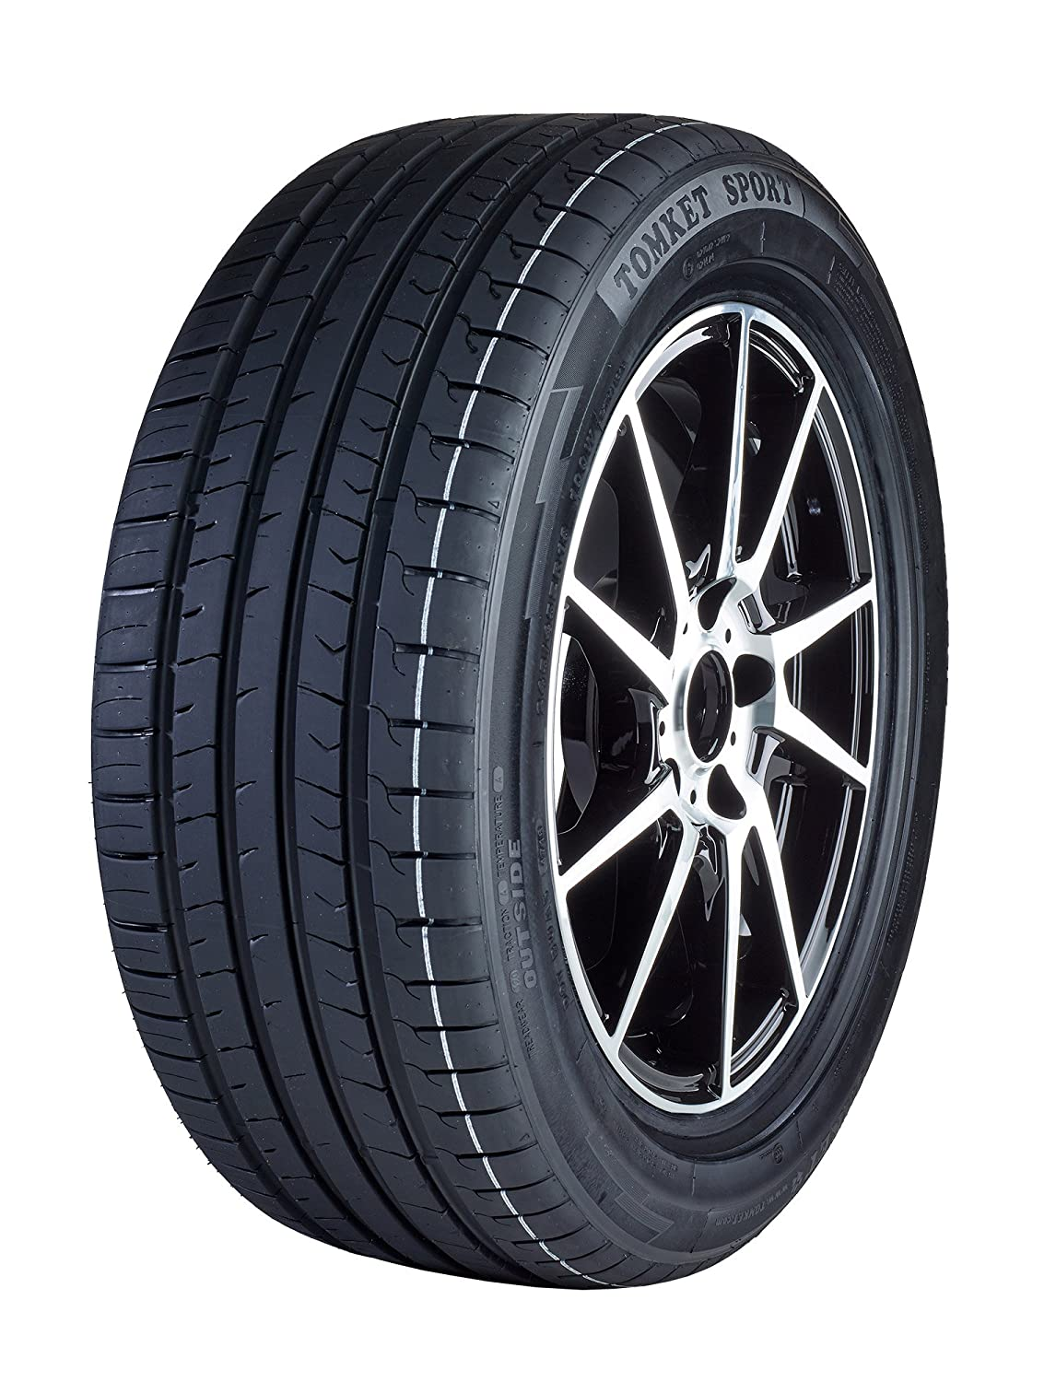

**PERFORMANCE TYRES**

BRAND NEW & QUALITY

PART WORN TYRES

VISIT DAVE NEIL

TEL: 07753 750841

**WHAT WE QUOTE IS**

**WHAT YOU PAY**



**FOR ALL YOUR BAIT REQUIREMENTS**

**POIGNDESTRE’S ANGLING CENTRE**

Unit 11, Southampton Trade Park

Third Ave, Millbrook, SO15 0AD

Tel: 02380 772958

**BILL’S BAIT & TACKLE**

16 Bridge Road, Woolston

Southampton, SO19 7GQ

Tel: 02380 446222

**OFFICERS & COMMITTEE MEMBERS**

HON PRESIDENT: PETER WALLACE HON VICE PRESIDENT: JOHN FARNWORTH

PRESIDENT: WAYNE BULLY VICE PRESIDENT: ROB COOKE

CHAIRMAN: DAVE NEIL: 07753 750841

mp-bigdave@hotmail.co.uk

VICE CHAIRMAN: DAVE BEALE: 07711 486098

Davebeale196@gmail.com

SECRETARY: ADEY GROVES: 07591 797736

Adey48@btinternet.com

TREASURER: MRS SUE PATTERSON: 023 80695701

suejanpatt@aol.com

MEMBERSHIP SEC: MRS CAROL GROVES: 02380 692786

cagroves@btinternet.com

MINUTES SEC: MRS NICOLA BEALE: 07929 756348

Nicki.beale@btinternet.com

RECORDS & WEBSITE: KEVIN DUNHAM: 0745 224501

dunhamk@sky.com

SHORE SIGNING ON OFFICERS: ROB COOKE: 02380 860504

robcooke1966@outlook.com

GAVIN PRIDAY: 07540 753620

Dandjwchythe@outlook.com

SHALLOW BOAT COMMODORES: JOHN RICHARDS: 07783 884028

richardsjune@hotmail.co.uk

BARRY INSTRELL: 079220 615145

b.instrell21@gmail.com

DEEP BOAT COMMODORE: RICHARD KNIGHT: 07773 054774

knightsmechanics@outlook.com

COMMITTEE: JIM MERRITT: 07778 128303

RICHARD DUNHAM 02380 861659

HENRY KING: 01329 834129